Capstone Project Report: Components (This page should not be included in final report)
Title Page: Prepare as per the format provided below

Abstract: The abstract should be a brief summary of your project, including the problem you addressed, your methodology, and your main findings or recommendations. It should be no more than 250 words.

Acknowledgement: To thank instructor, department chair and UoPeople University
Table of Contents: A table of contents should list all of the major sections of your report, including any subsections and their corresponding page numbers.
- List of Tables: It should be numbered and titled.
- List of Figures: It should be numbered and titled.
- Symbols and Abbreviations: The student can skip this section if there are no Symbols and Abbreviations in their project report

Introduction: The introduction should provide an overview of the project, including the problem statement, your research questions, and the scope of your study.

Literature Review: The literature review should summarize existing research on your topic and identify any gaps in the literature that your project addresses.

Methodology: The methodology section should describe the System architecture, Algorithmic design, data collection methods, and any analysis techniques used in your project.

Results: The results section should present the findings of your project, including any statistical analysis or visualizations that support your conclusions.

Discussion: The discussion should interpret the results of your capstone project in the context of the existing literature, address any limitations of your study, and provide recommendations for future research.
Conclusion: The conclusion should summarize your main findings and their implications, as well as the contributions of your project to the field.
References: The references section should list all of the sources cited in your report, formatted according to the citation style used by your university.

Appendices: The appendices should include any additional materials that support your research, such as raw data, survey questions, or code samples.
SemiFab Analytics
A Capstone Project Report of MSIT 5910

Submitted by:

Manoj Kumar Mahata (Student ID: S472973)

For the partial fulfilment of the requirements for the degree of
Master of Science in Information Technology

Supervised by:
Dr. Sirisha Pavuluri

Department of CS & MSIT
University of the People, Pasadena, CA 91101, United States
Term 5, July, 2026

ABSTRACT
The abstract should be a brief summary of your project, including the problem you addressed, your methodology, and your main findings or recommendations. It should be no more than 250 words. [TO BE UPDATED IN UNIT 7]

ACKNOWLEDGEMENT
To thank instructor, department chair and UoPeople University [TO BE UPDATED IN UNIT 7]

LIST OF TABLES
The student can skip this section if there are no tables in their project report. [TO BE UPDATED IN UNIT 7]

LIST OF FIGURES
The student can skip this section if there are no figures in their project report. [TO BE UPDATED IN UNIT 7]

SYMBOLS AND ABBREVIATIONS
The student can skip this section if there are no Symbols and Abbreviations in their project report [TO BE UPDATED IN UNIT 7]

CONTENTS

Abstract 3
Acknowledgement 4
List of Tables 4
List of Figures 4
Symbols and Abbreviations 4
Introduction 6
Sub Heading 1 6
Sub-sub heading 6
Sub Heading 2 6
Literature Review 7
Sub Heading 1 7
Sub-sub heading 7
Sub Heading 2 7
Methodology 8
Sub Heading 1 8
Sub-sub heading 8
Sub Heading 2 8
Results 8
Sub Heading 1 9
Sub-sub heading 9
Sub Heading 2 9
Discussion 9
Sub heading 1 10
Sub-sub heading 10
Subheading 2 10
Conclusion 10
Sub heading 1 11
Sub-sub heading 11
Subheading 2 11
References 11
Sub heading 1 12
Sub-sub heading 12
Sub heading 2 12
Appendices: 12
Sub heading 1 12
Sub-sub heading 12
Subheading 2 12

[TO BE UPDATED IN UNIT 7]

INTRODUCTION

The introduction should provide an overview of the project, including the problem statement, your research questions, and the scope of your study.

Sub Heading 1
Sub-sub heading

Sub Heading 2
Please take care of the following mechanics
Font: Times New Roman
Font Size: Chapter Heading: 24(bold), Heading:14(bold), Sub-heading: 12(bold and Italics) Normal Text(12)
Line spacing: 1.5-line spacing
Page margins :Page layout- 1 inch (2.54 cms) on all the sides
Page numbers to be included except for the content page and the cover page.
References with hanging indent
Tables and appendices to be labelled

1.1 Background of the Study
Write relevant content here.

1.2 Problem Statement
Write relevant content here.

1.3 Objectives of the Study
Write relevant content here.

1.4 Scope and Limitations
Write relevant content here.

1.5 Report Organization
Write relevant content here.

[TO BE UPDATED IN UNIT 7]

LITERATURE REVIEW
The literature review should summarize existing research on your topic and identify any gaps in the literature that your project addresses.

Sub Heading 1
Sub-sub heading

Sub Heading 2

Please take care of the following mechanics
Font: Times New Roman
Font Size: Chapter Heading: 24(bold), Heading:14(bold), Sub-heading: 12(bold and Italics) Normal Text(12)
Line spacing: 1.5-line spacing
Page margins :Page layout- 1 inch (2.54 cms) on all the sides
Page numbers to be included except for the content page and the cover page.
References with hanging indent
Tables and appendices to be labelled

2.1 Overview of Related Work
Write relevant content here.

2.2 Comparative Analysis of Existing Systems
Write relevant content here.

2.3 Research Gap Identification
Write relevant content here.

[TO BE UPDATED IN UNIT 7]

SYSTEM DESIGN
The methodology section should describe the Algorithmic design, data collection methods, and any analysis techniques used in your project.

Sub Heading 1
Sub-sub heading

Sub Heading 2

Please take care of the following mechanics
Font: Times New Roman
Font Size: Chapter Heading: 24(bold), Heading:14(bold), Sub-heading: 12(bold and Italics) Normal Text(12)
Line spacing: 1.5-line spacing
Page margins :Page layout- 1 inch (2.54 cms) on all the sides
Page numbers to be included except for the content page and the cover page.
References with hanging indent
Tables and appendices to be labelled

3.1 System Architecture
System Architecture diagram and explanation

3.2 Methodologies and Tools Used
Write relevant content here.(Algorithms, processes/logic of the project)

3.3 Data Flow and System Components
Write relevant content here. (Induvidual module diagrams with explanation)

3.4 Design Diagrams (DFD, UML, ER Diagram)
Write relevant content here. This is optional but will give clarity to your system

[TO BE UPDATED IN UNIT 7]

CHAPTER 4: RESULTS

4.1 Implementation Overview
The integrated workflow was designed to demonstrate how a manufacturing analytics application can transform raw process observations into useful decision-support information. The workflow begins with simulated wafer records because the project avoids the use of confidential factory data. Each record represents a wafer-level observation with lot, tool, lithography, contamination, defect, yield, and risk-related attributes. This structure allows the prototype to behave like a realistic semiconductor process-monitoring system while still remaining appropriate for an academic capstone project. The implementation therefore balances domain relevance, ethical data handling, and practical software development scope.
A major implementation result is the separation of responsibilities across modules. The data module creates a consistent input structure. The database module stores the generated records and verifies that all rows are loaded correctly. The analytics module calculates KPIs, SPC limits, Pareto results, and machine-learning outputs. The dashboard module presents these results to the user. This separation reduces complexity because each module has a clear purpose. It also improves maintainability because later changes can be made to one part of the system without rewriting the entire application.
The integration runner acts as the connecting layer between these modules. It calls the data generator, passes the dataset to the database layer, retrieves or validates row counts, sends the dataset to the analytics functions, and prints a consolidated output summary. This output summary is important because it shows that the modules do not only exist as isolated scripts. They work together as one system and produce a coherent result. For Unit 6, this integrated execution is the strongest evidence that the capstone project moved from design and isolated logic toward a working prototype.
This chapter presents the implementation results of SemiFab Analytics, a semiconductor process analytics prototype that integrates simulated wafer data, database persistence, process-control analytics, machine-learning quality prediction, and dashboard visualization. The implementation follows the capstone architecture developed in earlier units, but Unit 6 moves the project from isolated module outputs toward a connected application workflow. The system is not intended to represent a production semiconductor manufacturing execution system. Instead, it demonstrates how a realistic academic prototype can combine data engineering, analytics, testing, visualization, and deployment planning for process-quality decision support.
The implemented system has five main source modules. The first is the data generation module, which produces simulated wafer and lithography records with wafer IDs, lot IDs, tool IDs, process dates, failure patterns, contamination scores, defect densities, and yield percentages. The second is the database module, which stores and retrieves records so that the system demonstrates a backend persistence layer rather than only in-memory analysis. The third is the analytics module, which calculates KPI values, SPC-style limits, failure-pattern Pareto summaries, machine-learning model accuracy, latency values, and feature importance. The fourth is the integration runner, which coordinates data generation, database loading, analytics execution, and output reporting. The fifth is the dashboard module, which presents KPI cards, charts, and a lot-level risk table using Streamlit.
The core implementation result is that all modules execute together. In the final integration run, the system generated 360 wafer records and loaded 360 records into the database. The equal input and database row counts confirm that the data pipeline worked consistently. The integrated output also reported KPI values including average yield of 80.87%, pass rate of 26.39%, estimated total defects of 7,320, average defects per wafer of 2.033, and 46 high-contamination wafers. These values demonstrate that the prototype converts raw simulated measurements into operational metrics that can be interpreted by process engineers or quality analysts.
The analytics layer also implements SPC-style monitoring. Defect density was selected as the main process-control metric because it directly connects wafer quality, yield loss, and engineering action. The system calculated a mean defect density of 2.033, an upper control limit of 3.374, a lower control limit of 0.692, and three out-of-control records. This result is important because it shows that the prototype can identify unusual process behavior instead of only reporting averages. In a real manufacturing environment, such abnormal records would not automatically prove product failure; they would trigger review by process and quality specialists.
The machine-learning component completed a pass/fail classification task with model accuracy of 0.756. The top features included defect_density, contamination_score, resist_thickness, cd_mean, and exposure_dose. This feature ranking is technically meaningful because it links prediction behavior to process-related variables rather than making the model a black box. The implementation therefore supports model explainability at a basic level. The system also generated a requires-review count of 188 wafers. The phrase requires review was intentionally used to support responsible decision-making: the dashboard should assist human judgment, not replace engineering investigation.
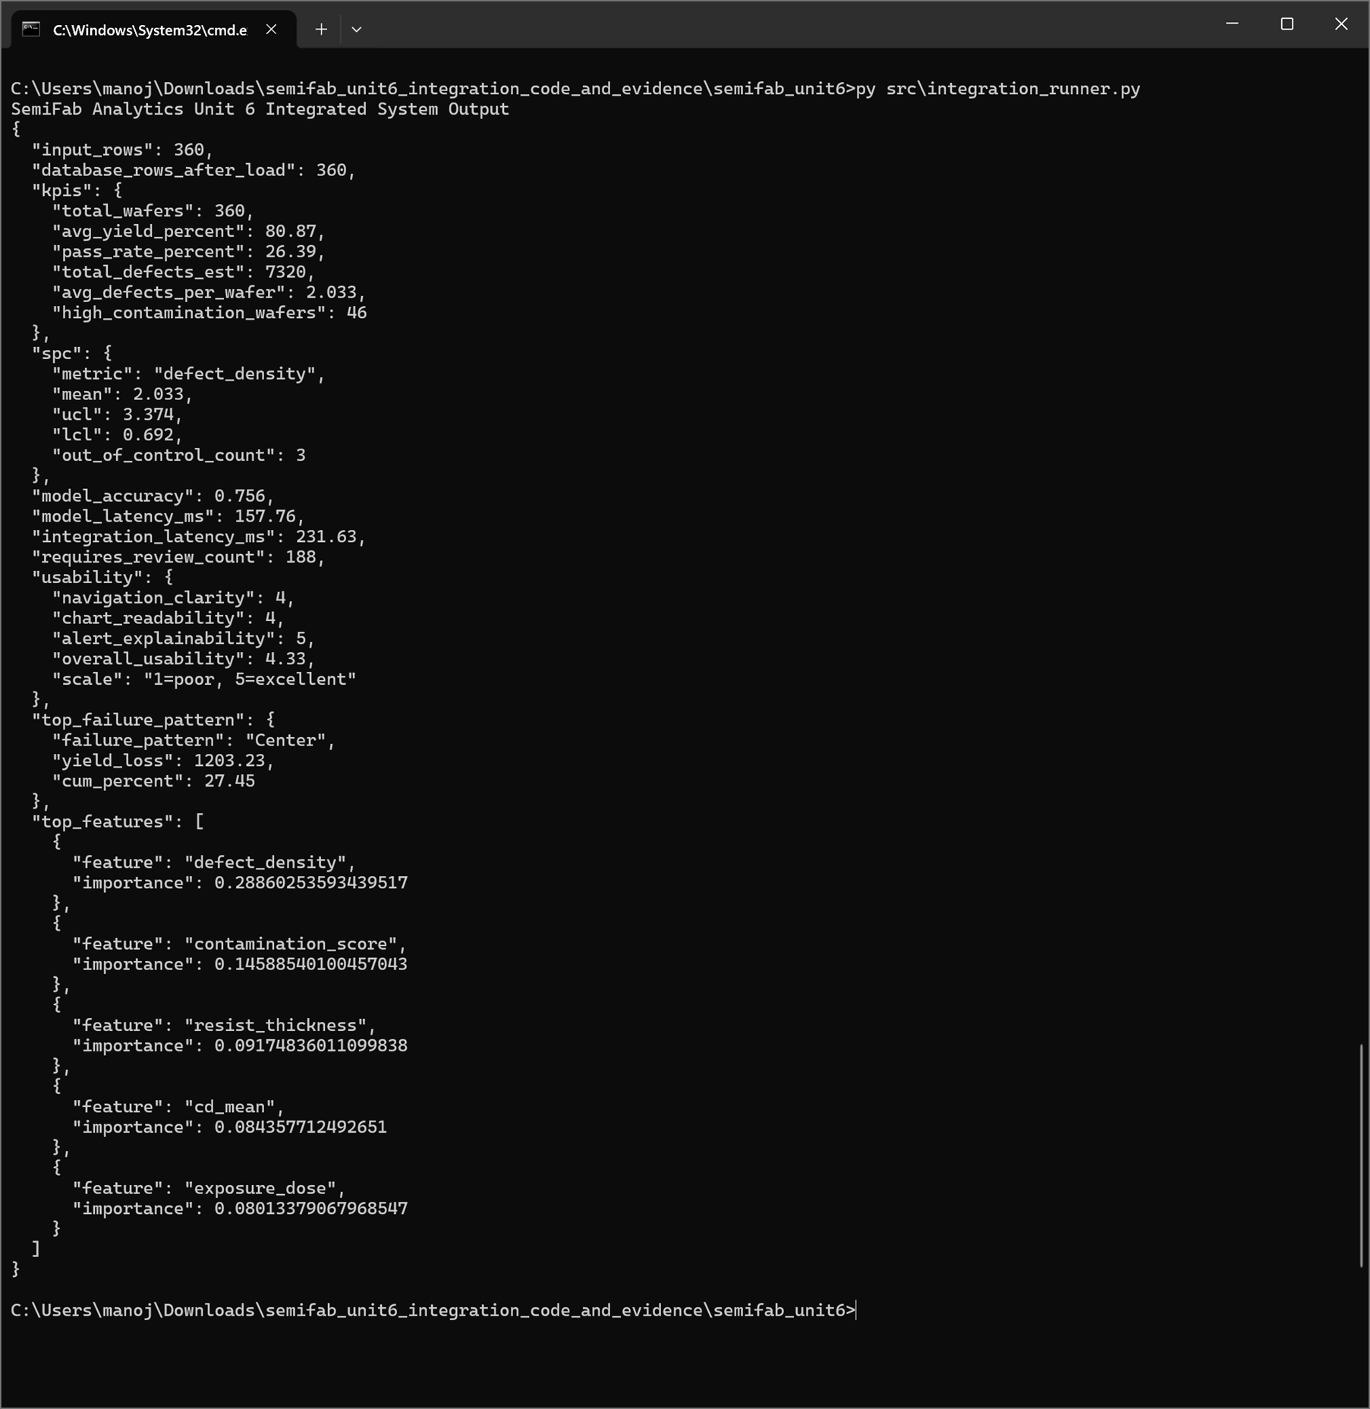
Figure 4.1. Integrated system output showing data loading, KPI calculation, SPC results, model accuracy, latency, usability score, failure-pattern analysis, and feature importance.

4.2 Output and Screenshots
The command-line output is useful because it provides a direct, reproducible record of system behavior. It shows the number of input rows, the number of rows loaded into the database, KPI values, SPC values, model accuracy, latency values, usability score, top failure pattern, and feature-importance results. This information is more than a simple print statement; it is a compact evidence report generated by the integrated workflow. The equal input and database row counts confirm that the system did not lose records during loading. This is an essential validation step for any analytics system that depends on trustworthy data movement.
The dashboard screenshot provides a second type of evidence. While the command line is useful for the developer, the dashboard is more useful for an end user such as a process engineer, quality analyst, or manufacturing data analyst. The KPI cards allow quick inspection of total wafers, average yield, pass rate, and wafers requiring review. The charts make the results easier to interpret visually. For example, yield loss by failure pattern helps identify which wafer map pattern contributes most to performance loss, while defect density by tool supports tool-level comparison. The lot-level risk table turns summary analytics into an actionable review list.
The PyTest screenshot adds testing evidence to the results chapter. Testing is important because integration work can fail even when individual functions appear correct. The successful integration test confirms that the main workflow can execute without error and that expected outputs are produced. This does not prove that the application is complete or production-ready, but it demonstrates that the Unit 6 prototype is functional and testable. The screenshot also supports version-control traceability because it can be linked to the corresponding GitHub code and release milestone.
The output screenshots demonstrate that the integration is visible at both the command-line and dashboard levels. The command-line output verifies backend operation: data are generated, loaded, evaluated, and summarized. The dashboard screenshot verifies frontend presentation: the same system outputs are converted into KPI cards, visualizations, and a risk table. Together, these screenshots satisfy the requirement to show input-output behavior and module integration evidence.
The Streamlit dashboard is titled SemiFab Analytics: Process, Defect, Yield, SPC, and Risk Dashboard. It presents total wafers, average yield, pass rate, and requires-review count as KPI cards. It also includes a yield-loss-by-failure-pattern chart, a defect-density-by-tool chart, and a lot-level risk table. The dashboard therefore combines ideas from manufacturing KPI dashboards and wafer failure-pattern analysis while preserving the original project focus on lithography process analytics, contamination risk, SPC monitoring, and ML-assisted quality prediction.
The lot-level risk table is especially important because it gives users a concrete list of wafers or lots that need attention. A dashboard that only shows high-level averages can hide individual risk records. The lot-level table connects each wafer to lot ID, tool ID, failure pattern, contamination score, defect density, yield percentage, and risk status. This improves traceability and makes the prototype more useful for process-quality review. The failure-pattern chart adds another semiconductor-specific layer by identifying which patterns contribute most to yield loss. The top failure pattern in the integration output was Center, with yield loss of 1203.23 and cumulative percentage of 27.45%.
The PyTest output provides test evidence. The Unit 6 integration test completed successfully with one test passed. Although the current test set is still small, it verifies that the integrated system can run after module connection. This result builds on the Unit 5 testing work and demonstrates that testing remains part of the project workflow. The testing screenshot is included because the assignment requires evidence of implementation validation and system performance.
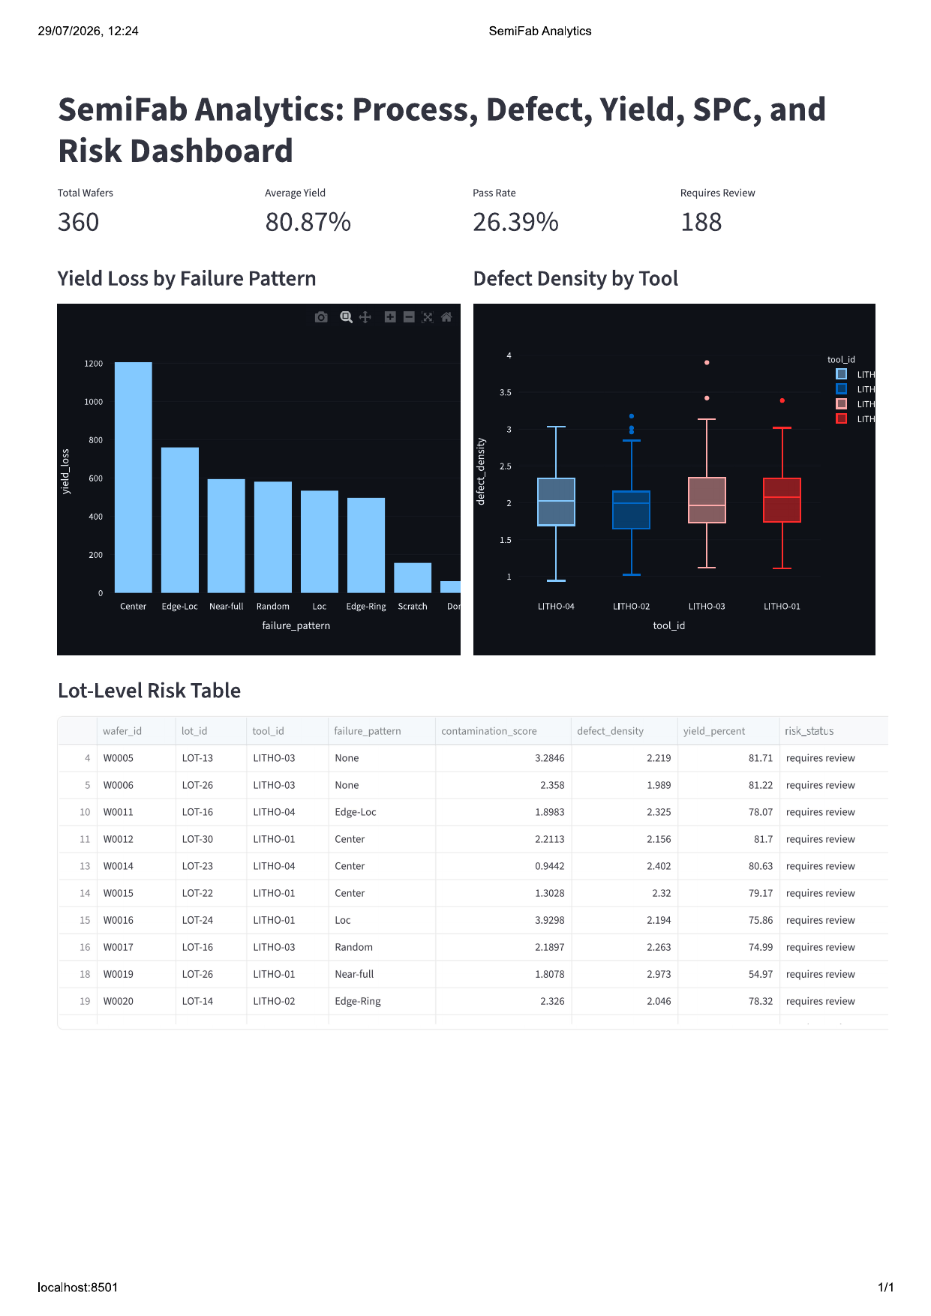
Figure 4.2. Streamlit dashboard showing KPI cards, yield-loss analysis, defect-density comparison, and lot-level risk table.
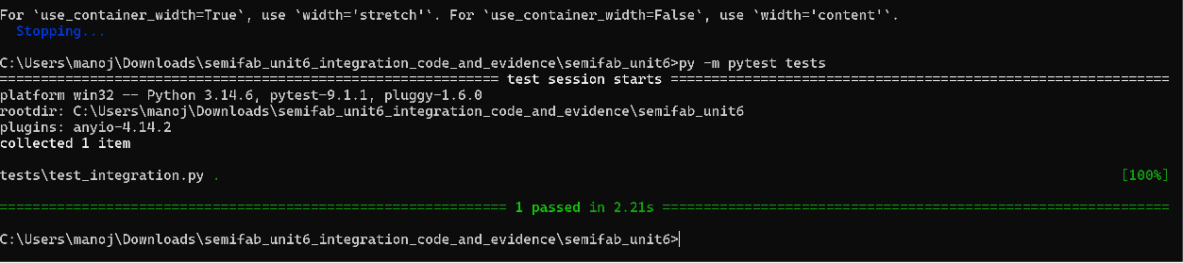
Figure 4.3. PyTest execution log showing successful completion of the Unit 6 integration test.

4.3 Evaluation Metrics
The selected metrics were chosen to reflect both analytical performance and software performance. Model accuracy evaluates whether the machine-learning component can learn a useful relationship between input features and the simulated pass/fail result. Latency evaluates whether the system responds quickly enough for interactive analysis. Row-count validation evaluates whether data integration is reliable. The qualitative usability score evaluates whether the dashboard communicates results clearly. Together, these metrics provide a broader evaluation than model accuracy alone.
The accuracy value of 0.756 should be interpreted carefully. Because the dataset is simulated, the value does not represent proven real-factory performance. However, it shows that the model can detect patterns within the designed simulation. The feature-importance results also make the model more interpretable. Defect density and contamination score appearing as important variables is reasonable because both are logically connected to yield loss and wafer risk. This supports the internal consistency of the prototype and provides a basis for later improvement when more realistic or real production data become available.
The latency measurements indicate that the prototype can run quickly in a local development environment. A model latency of about 157.76 ms and an integration latency of about 231.63 ms are acceptable for a dashboard-style system where users refresh reports or inspect lots rather than control equipment in real time. These values suggest that the selected architecture is lightweight enough for classroom demonstration and early-stage prototyping. If the project later processes larger datasets or adds real-time tool data, additional performance tests such as throughput, memory use, and concurrent-user response time would be required.
The qualitative usability score of 4.33 out of 5 was used as a simple interface clarity indicator. It considered navigation clarity, chart readability, and alert explainability. This metric is not as rigorous as a formal user study, but it is appropriate for an academic prototype at this stage. It shows that the dashboard design is understandable and that the risk alerts are explainable enough for a user to know why records require review. Future evaluation should include feedback from multiple users, especially users with manufacturing, analytics, or quality-control backgrounds.
The system was evaluated using a mixture of quantitative and qualitative metrics. Quantitative metrics were selected to measure prediction quality, response speed, integration success, and testing status. Qualitative metrics were selected to evaluate whether the dashboard could be understood by users. Table 4.1 summarizes the evaluation results.
Metric | Measured Result | Interpretation
Input/database consistency | 360 input rows and 360 database rows | Data pipeline successfully preserved all records
Average yield | 80.87% | Shows wafer quality performance in the simulated dataset
Pass rate | 26.39% | Indicates strict simulated pass/fail threshold and high-risk dataset
SPC out-of-control count | 3 | Highlights abnormal defect-density observations
Model accuracy | 0.756 | Shows working ML classification capability
Model latency | 157.76 ms | Suitable for small interactive prototype
Integration latency | 231.63 ms | End-to-end workflow executes quickly
Requires review count | 188 | Provides actionable risk-alert list
Overall usability | 4.33/5 | Dashboard is clear and interpretable
PyTest result | 1 passed in 2.21 s | Integrated workflow test completed successfully

Table 4.1. System evaluation metrics for the Unit 6 integrated prototype.
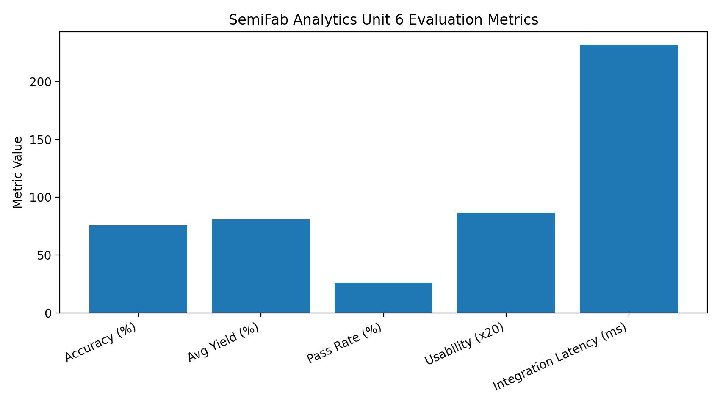
Figure 4.4. Visualization of selected evaluation metrics for the integrated prototype.
The model accuracy of 0.756 indicates that the prototype can learn useful relationships between process variables and the simulated pass/fail outcome. The result should not be interpreted as production-level performance because the data are simulated and the model has not been validated on real manufacturing data. However, the result is appropriate for the project stage because it demonstrates an end-to-end ML workflow: data preparation, feature selection, model training, evaluation, and feature-importance interpretation. scikit-learn supports feature-importance analysis in tree-based models, which allows users to inspect which features most strongly influence model behavior (scikit-learn developers, 2025).
Latency results were also acceptable for a local prototype. The model latency of 157.76 ms and integration latency of 231.63 ms show that the workflow can execute in less than one second on the simulated dataset. This is not a full scalability test, but it supports interactive use during academic demonstration. Future work should test larger datasets, database indexing, caching, and dashboard responsiveness under heavier workloads.

CHAPTER 5: DISCUSSION

5.1 Interpretation of Results
The integration result is significant because the project combines multiple concerns that are often separated in early prototypes: data creation, data persistence, analytics, prediction, visualization, testing, and deployment planning. A simple dashboard can be built by loading a CSV file directly into a plotting tool, but SemiFab Analytics goes further by including a database layer, validation logic, SPC-style calculations, and machine-learning interpretation. This makes the project more realistic as a software engineering capstone, because it demonstrates both data-analysis thinking and system-integration thinking.
The row-count validation result is especially important from a data-quality perspective. In manufacturing analytics, incorrect data transfer can lead to misleading conclusions, such as undercounted defects, incorrect yield percentages, or missed high-risk lots. The system output showing 360 input rows and 360 database rows after loading gives a simple but useful assurance that the integration path is working. In future versions, this validation could be extended to schema validation, duplicate detection, missing-value checks, and range checks for process variables.
The risk-status output also has practical meaning. The system identified 188 wafers requiring review. This number may appear high, but in the context of a simulated dataset it demonstrates that the alert logic is active and that the dashboard can separate normal records from records needing attention. In a real system, the threshold would need to be calibrated carefully with process engineers. Too many alerts could create alert fatigue, while too few alerts could miss important process excursions. Therefore, threshold design is both a technical and operational decision.
The Unit 6 results show that SemiFab Analytics has moved from a collection of planned modules to an integrated prototype. The most important finding is that the system can process simulated wafer data through a complete workflow: generate records, store records, calculate KPIs, identify SPC anomalies, train a machine-learning model, create risk alerts, and display results in a dashboard. This demonstrates the feasibility of the original capstone objective: to build a semiconductor process analytics dashboard for lithography monitoring, contamination analysis, defect trends, SPC-style process control, and process-quality prediction.
The KPI results are meaningful because they support fast operational understanding. Total wafers and average yield provide a high-level view of manufacturing performance. Pass rate and requires-review count show the severity of risk conditions. High-contamination wafers provide a contamination-specific indicator, which is directly aligned with the project’s scientific and process-control motivation. The dashboard design gives users immediate visibility into these indicators and connects them to charts and lot-level details.
The SPC result strengthens the system by adding a process-control perspective. Averages alone do not reveal whether a process is stable. By calculating mean, upper control limit, lower control limit, and out-of-control count, the system identifies process behavior that may require investigation. In the prototype, three records were outside the defect-density control limits. This does not mean those wafers must be rejected; it means they should be reviewed. This distinction is important for ethical and practical decision support.
The model results show that predictive analytics can be integrated into the dashboard workflow. The model accuracy of 0.756 suggests that the simulated variables contain signal related to pass/fail classification. The top features also make practical sense: defect density and contamination score should be related to yield risk, while lithography variables such as resist thickness, critical dimension mean, and exposure dose are plausible contributors to process-quality outcomes. The dashboard therefore does not merely report a risk score; it also provides some explanation of the variables associated with that risk.

5.2 Comparison with Literature Findings
The literature on wafer map classification and defect-pattern analysis often focuses on advanced modeling techniques, including deep learning, semi-supervised learning, and representation learning. Those methods are valuable when large labelled datasets are available. The current capstone project does not attempt to reproduce that level of algorithmic complexity. Instead, it translates the same general idea into a dashboard-oriented decision-support system. The emphasis is not only on classification but also on integration, usability, traceability, and deployment readiness.
The project also reflects the broader movement toward data-driven manufacturing. Semiconductor production involves many process steps, tools, lots, wafers, and measurements. Literature and industrial practice both show that analytics systems must connect data from different sources before meaningful decisions can be made. SemiFab Analytics follows this principle by combining simulated process variables, defect variables, yield metrics, failure-pattern categories, and risk logic in one workflow. The result is a small-scale version of the kind of integrated analytics environment used in advanced manufacturing.
Compared with full industrial systems, the prototype is limited in scale and data realism. Industrial semiconductor analytics may include equipment sensor streams, recipe histories, maintenance logs, fab scheduling data, inspection images, metrology files, and manufacturing execution system records. SemiFab Analytics uses a simplified wafer-level dataset because the project must remain feasible and avoid confidential information. Even with this simplification, the project demonstrates the core concept that defect, process, yield, and risk information should be analyzed together rather than separately.
The project results align with current semiconductor defect-analysis literature. Recent wafer map research emphasizes that defect pattern analysis can support yield improvement and manufacturing issue detection. Wei et al. (2023) describe wafer map defect-pattern classification as an important step in reducing manual inspection effort. Bao et al. (2024) further show that wafer defect maps can be used to diagnose manufacturing problems, although noisy data, class imbalance, and complex failure modes remain challenges. Mishra et al. (2024) also demonstrate the value of data-driven wafer map pattern classification for yield-related analysis.
Compared with these research studies, SemiFab Analytics is intentionally simpler. It does not attempt to implement advanced deep learning or spiking neural networks. Instead, it focuses on building an understandable engineering dashboard that connects process variables, defect patterns, SPC limits, and quality prediction. This is an important practical difference. A highly accurate model can still be difficult to use if process engineers cannot connect the result to tools, lots, contamination scores, or failure patterns. The project therefore addresses a practical gap between research-level algorithms and dashboard-level engineering decision support.
The dashboard also aligns with modern data-engineering practice. Semiconductor manufacturing data often come from different tools, lots, and process steps, so analytics systems benefit from clear data pipelines and standardized models. The project uses a simple local structure rather than a full enterprise data warehouse, but the same principle applies: raw data must be transformed into trusted, visible, and explainable metrics. The Streamlit deployment approach is appropriate because Streamlit Community Cloud can deploy an app from a GitHub repository by selecting the repository, branch, and entrypoint file (Streamlit, 2026). This gives the capstone a realistic deployment pathway without requiring complex infrastructure.
The security and configuration discussion is also consistent with professional guidance. NIST SP 800-218 recommends secure software development practices that can be integrated into the software development life cycle to reduce vulnerability risk (NIST, 2022). OWASP identifies broken access control, cryptographic failures, insecure design, and security misconfiguration among major web application risks (OWASP Foundation, 2021). SemiFab Analytics currently uses simulated data, but it is designed with future data sensitivity in mind. This is why the deployment plan includes repository access control, no committed secrets, documented dependencies, and future authentication planning.

5.3 Implications and Limitations
The educational implication of the project is that it demonstrates a complete path from concept to integration. Earlier units focused on planning, architecture, ethical issues, core logic, testing, and version control. Unit 6 connects these pieces into one working milestone. This reflects an important software engineering lesson: a project is not complete when individual functions work; it becomes useful when the functions communicate reliably and produce outputs that users can interpret.
The professional implication is that the project supports the type of work performed by process-control analysts, manufacturing data analysts, quality analysts, and semiconductor data engineers. These roles often require the ability to connect domain knowledge with data tools. SemiFab Analytics demonstrates this combination by using semiconductor process concepts such as yield, defect density, contamination, lithography parameters, SPC limits, wafer failure patterns, and risk review logic while also using Python, database handling, machine learning, dashboarding, testing, and GitHub releases.
A key limitation is that the usability assessment is preliminary. The score was based on clarity factors such as navigation, chart readability, and alert explainability, but it was not collected through a controlled study with multiple external users. A stronger evaluation would ask several users to complete tasks, such as identifying the highest-risk lot, interpreting a defect-density chart, or finding the top yield-loss pattern. Task completion time, error rate, and user comments would provide stronger evidence of dashboard usability.
Another limitation is that the current deployment plan is not yet a full production deployment. Streamlit Community Cloud or local Streamlit execution is suitable for demonstration, but a real manufacturing environment would require stricter controls. These would include authentication, authorization, secrets management, network restrictions, audit logs, backup procedures, dependency scanning, and monitoring. The current plan describes the path toward deployment, but the final production architecture would need additional security and operational work.
The main implication of the project is that a relatively lightweight Python-based system can demonstrate meaningful semiconductor process analytics. Even without real production data, the prototype shows how process variables, defect-density indicators, contamination scores, and yield metrics can be combined into an integrated decision-support workflow. This has professional value because process engineers and quality analysts often need fast interpretation of process drift, lot-level risk, and defect patterns.
Another implication is that explainability should be included in analytics dashboards. SemiFab Analytics reports top model features so that users can see which variables contributed most strongly to the prediction model. It also uses the label requires review rather than automatic failure. This supports human-in-the-loop decision-making and avoids overclaiming the reliability of a simulated model. In manufacturing settings, this is important because incorrect automated decisions could affect yield, production schedules, or quality disposition.
The project also demonstrates the value of version control and testing. GitHub branches, commits, screenshots, and release tags provide traceability. The Unit 6 release tag v0.3-system-integration records a milestone where integration, dashboard output, testing, metrics, and deployment planning were completed. This supports project monitoring and review. Automated testing with PyTest provides a basic quality gate before the system is considered integrated.
The limitations are significant and must be acknowledged. First, the data are simulated and therefore cannot prove real-world semiconductor model performance. Second, the model accuracy is based on generated labels and may not generalize to real wafer fabrication data. Third, the dashboard currently runs as a local or simple Streamlit application and does not include production authentication, role-based access, encrypted databases, or industrial-grade logging. Fourth, the current PyTest coverage is still limited and should be expanded to include negative tests, boundary tests, database failure cases, and dashboard component tests. Fifth, the current data model is simplified; a full implementation would benefit from a star schema with fact and dimension tables for wafer process records, tools, lots, process steps, defects, and dates.

5.4 Future Work
Future work should also improve the data model. A stronger version of the system could use a star-schema design with fact and dimension tables, such as a wafer-process fact table and separate dimension tables for tools, lots, dates, processes, and defect categories. This would make the project more similar to a data warehouse and would support more flexible dashboard filtering. It would also allow better historical analysis, such as comparing tools over time, studying lots from a specific date range, or analyzing defect types by process step.
Another future improvement is deeper SPC functionality. The current prototype calculates mean, UCL, LCL, and out-of-control count for defect density. A more complete system could include control charts for overlay error, CD mean, CD uniformity, contamination score, and particle count. It could also include Western Electric-style rules, trend detection, moving averages, and separate limits by tool or recipe. These additions would make the dashboard more useful for process-monitoring and excursion-detection tasks.
The machine-learning component can also be extended. Future versions could compare several models, such as logistic regression, random forest, gradient boosting, and support vector machines. Model comparison should include accuracy, precision, recall, F1-score, confusion matrix, and calibration. Because missed high-risk wafers may be more serious than false alarms, recall for failure or high-risk classes could become more important than overall accuracy. Explainability methods such as feature importance or SHAP values could help users understand why the model produces certain risk predictions.
Finally, the deployment pipeline should become more automated. GitHub Actions could run tests automatically whenever code is pushed. A Dockerfile could make the environment reproducible across machines. A requirements file should pin package versions to reduce dependency problems. Environment variables should store configuration values such as database path, application mode, and security settings. A release checklist could confirm that tests pass, screenshots are updated, documentation is complete, and the dashboard runs successfully before each tagged release.
Future work should focus on four areas: data realism, dashboard depth, deployment maturity, and testing coverage. Data realism can be improved by adding more detailed lithography parameters, maintenance variables, die-size categories, process-step identifiers, and wafer map coordinates. The current final-project plan already identifies useful extensions such as failure patterns including Center, Edge-Loc, Edge-Ring, Loc, Near-full, Random, Scratch, Donut, and None. These categories can be connected to yield-loss Pareto charts and wafer map visualizations.
Dashboard depth can be improved by adding separate pages for executive KPIs, lithography process monitoring, SPC charts, wafer failure-pattern analysis, and model explainability. The dashboard should also include filters for lot ID, tool ID, process month, failure pattern, and risk status. This would make the tool more useful for process review and root-cause investigation. A future version should also include a wafer-map view, where individual die or wafer regions are shown visually.
Deployment maturity can be improved through Streamlit Community Cloud deployment, Docker packaging, and GitHub Actions CI. The repository should include a requirements.txt file, README instructions, release notes, test commands, and screenshots. GitHub Actions can run tests automatically on each push, while Streamlit Cloud can redeploy the dashboard after approved commits. This would create a more professional workflow and show stronger alignment with CI/CD concepts studied in Unit 4.
Testing coverage should be expanded beyond one integration test. Future tests should verify data-schema consistency, KPI calculations, SPC boundary cases, model output shape, failure-pattern aggregation, empty input handling, invalid data handling, and dashboard data preparation. This will make the system more reliable and easier to modify. The final capstone should also include a clear security and ethics section explaining that the prototype uses simulated data, does not process personal data, and would require stronger access control before using proprietary manufacturing data.

CHAPTER 6: CONCLUSION

The Unit 6 work confirms that the project is no longer only a proposal or design document. It has become an integrated prototype with executable code, dashboard output, testing evidence, evaluation metrics, and a deployment plan. The results show that simulated semiconductor wafer data can be transformed into operational information through a structured Python workflow. The system generates data, loads it into a database, validates row counts, calculates KPIs, applies SPC-style monitoring, trains a classification model, reports important features, and presents results in a dashboard.
The findings imply that even a lightweight academic system can represent important ideas from semiconductor manufacturing analytics. Yield, defect density, contamination, process variation, wafer failure patterns, and risk review are interconnected. A dashboard that brings these elements together can support better understanding than separate spreadsheets or isolated scripts. Although the prototype uses simulated data, it provides a foundation that could later be adapted for more realistic datasets, stronger models, and more secure deployment.
The main contribution of the project is the combination of domain-specific semiconductor concepts with practical software engineering methods. The project does not only show charts; it also shows integration, modularity, testing, version control, release management, and deployment planning. These are important for building trustworthy analytics tools. The project also demonstrates responsible scope management by avoiding confidential production data and clearly stating that the dataset is simulated.
Several lessons were learned during the implementation. Clear module boundaries made integration easier. Reproducible commands made testing and evidence collection easier. Screenshots, GitHub commits, and releases improved traceability. At the same time, the work showed that dashboard development requires careful thinking about users, not only code. A useful analytics tool must present results in a way that helps users make decisions. For this reason, risk tables, KPI cards, charts, and explainability outputs are important parts of the system.
The next improvements should focus on completing the final capstone report, strengthening the dataset, expanding the dashboard, adding more tests, and improving deployment readiness. The final system should include clearer documentation, final screenshots, a stable GitHub release, and a polished user guide. With these improvements, SemiFab Analytics can become a strong capstone demonstration of how information technology, data analytics, machine learning, and semiconductor process knowledge can be combined in a practical decision-support application.
The Unit 6 implementation demonstrates that SemiFab Analytics can function as an integrated semiconductor process analytics prototype. The system successfully connects simulated wafer data generation, database loading, KPI calculation, SPC-style defect-density monitoring, machine-learning pass/fail prediction, risk-alert generation, dashboard visualization, PyTest validation, and deployment planning. The integrated output confirms 360 input records and 360 database rows, showing that the data pipeline worked correctly. It also reports average yield, pass rate, defect estimates, high-contamination counts, SPC limits, model accuracy, latency, usability, top failure pattern, and feature importance.
The main finding is that the prototype can transform simulated semiconductor process data into useful engineering information. The KPI dashboard provides quick operational visibility. The SPC calculation identifies abnormal defect-density behavior. The ML model provides a predictive quality signal. The feature-importance output supports basic explainability. The lot-level risk table supports practical review by showing specific wafers or lots requiring attention. Together, these components show that the system is not only a charting exercise but an integrated decision-support prototype.
The project contributes to the field by demonstrating how data analytics, machine learning, software engineering, testing, and secure deployment planning can be combined for semiconductor manufacturing decision support. It is especially relevant because semiconductor yield improvement depends on identifying process drift, contamination indicators, defect-density patterns, and tool-related quality risks. The prototype does not replace advanced fab systems or research-grade defect classifiers, but it provides a practical bridge between raw process data and engineering interpretation.
Several lessons were learned. First, system integration requires clear module boundaries; data generation, database operations, analytics, dashboard code, and tests should be separated but connected through well-defined inputs and outputs. Second, screenshots and metrics are important because they demonstrate working functionality more convincingly than text alone. Third, testing should be introduced early because even small integration changes can create errors. Fourth, deployment planning should begin before final delivery because file structure, dependencies, and configuration choices affect whether the system can run on another machine or cloud environment.
The main challenges were scope control, realistic data simulation, and balancing technical depth with feasibility. Semiconductor manufacturing is a complex domain, and a student capstone cannot reproduce an industrial fab data platform. This challenge was addressed by focusing on a feasible minimum viable product: simulated data, local database loading, process KPIs, SPC logic, a simple ML model, risk alerts, a Streamlit dashboard, and PyTest validation. The project can be improved further by adding wafer map visualization, a stronger star-schema database, more test coverage, Docker deployment, GitHub Actions CI, and real-time dashboard filters.
In conclusion, SemiFab Analytics has reached the Unit 6 milestone as a working integrated prototype with evaluation evidence and deployment planning. The next improvements should focus on richer dashboard pages, stronger data modeling, expanded testing, and a final capstone release. These improvements will make the project more suitable as a professional portfolio artifact for roles such as Manufacturing Data Analyst, Quality Data Analyst, Process Control Analyst, Laboratory Data Analyst, or Semiconductor Process Data Analyst.

REFERENCES

Bao, Y.-Y., Li, E.-C., Yang, H.-Q., & Jia, B.-B. (2024). Wafer map defect classification using autoencoder-based data augmentation and convolutional neural network. arXiv. https://arxiv.org/abs/2411.11029
GitHub Docs. (2026). About continuous integration. https://docs.github.com/en/actions/get-started/continuous-integration
Mishra, A., Kumar, S., Lingamoorthy, A., Das, A., & Kandasamy, N. (2024). Wafer2Spike: Spiking neural network for wafer map pattern classification. arXiv. https://arxiv.org/abs/2411.19422
National Institute of Standards and Technology. (2022). Secure Software Development Framework (SSDF) Version 1.1: Recommendations for mitigating the risk of software vulnerabilities (NIST SP 800-218). https://doi.org/10.6028/NIST.SP.800-218
OWASP Foundation. (2021). OWASP Top 10:2021. https://owasp.org/Top10/
pytest. (2026). How to invoke pytest. https://docs.pytest.org/
scikit-learn developers. (2025). Feature importances with a forest of trees. https://scikit-learn.org/
Streamlit. (2026). Deploy your app on Community Cloud. https://docs.streamlit.io/deploy/streamlit-community-cloud/deploy-your-app/deploy
Wei, Q., Zhao, W., Zheng, X., & Zeng, Z. (2023). Wafer map defect patterns semi-supervised classification using latent vector representation. arXiv. https://arxiv.org/abs/2311.12840

APPENDICES:
The appendices should include any additional materials that support your, such as raw data, survey questions, or code samples.

Sub heading 1
Sub-sub heading

Subheading 2
Please take care of the following mechanics
Font: Times New Roman
Font Size-12
Line spacing: 1.5-line spacing
Page margins :Page layout- 1 inch (2.54 cms) on all the sides
Page numbers to be included except for the content page and the cover page.
References with hanging indent
Tables and appendices to be labelled
[TO BE UPDATED]

